Step 1: Created a bucket ( j-que4-buck ) in google cloud storage

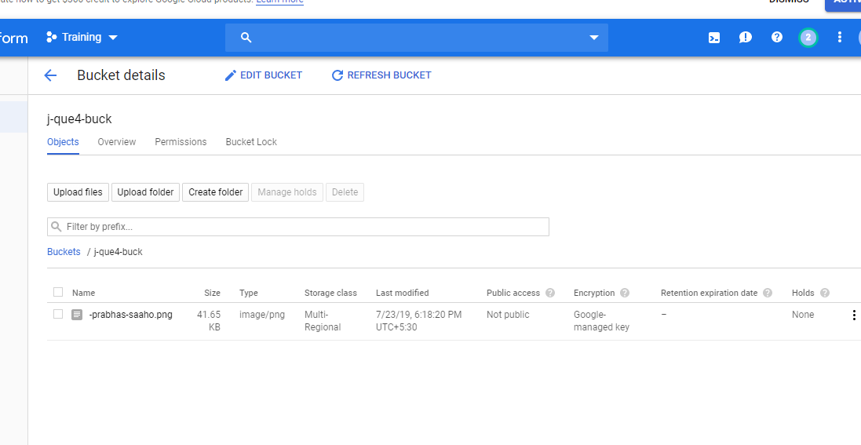

- Created a cloud function ( serverless architecture ) and added the above bucket as a trigger.

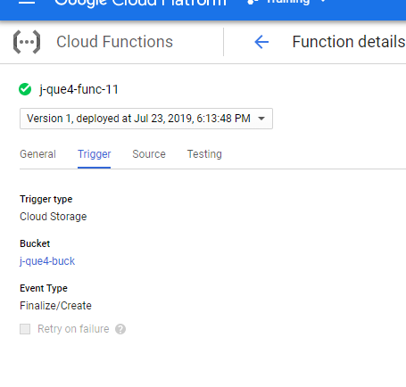

- Python Code :

from google.cloud import vision
from google.cloud.vision import types

class MyError(Exception):
pass

def detect_labels(uri):
client = vision.ImageAnnotatorClient()
image = vision.types.Image()
image.source.image_uri = uri
response = client.label_detection(image=image)
labels = response.label_annotations
print('Labels:')
print(labels)

for label in labels:
print(label.description)

def hello_gcs(event, context):
formats = ["image/jpeg", "image/png", "image/gif", "image/bmp", "image/webp", "image/x-icon", "application/pdf", "image/tiff"]
file_name = event['name']
file_type = event['contentType']
uri_path = "gs://j-que4-buck/" + file_name
try:
if file_type not in formats:
raise MyError
detect_labels(uri_path)
except MyError:
print("Error : File Format is not image! Its " + file_type)

- We have added an image to GCS bucket ,taking it as an event, the cloud function got triggered

and it will detect the objects from the image that we have uploaded.

- The extracted information about the objects in the uploaded image is logged and is shown as below.

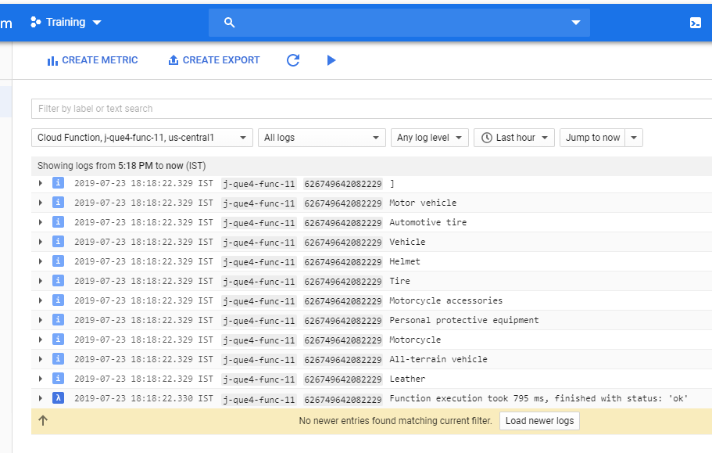

Error handling:

The architecture also has error handling that whenever we upload a file other than the image ( not

an image format ) then it will throw an exception.

